Bernard Owusu Sefah

Pre-Lab 7: 2 Bit Binary Adder

Task 1

|  |  |  |  |  |  |  |  |  |  |
| --- | --- | --- | --- | --- | --- | --- | --- | --- | --- |
| INPUTS |  |  |  | Outputs (when C=Low) |  |  | Outputs (when C=High) |  |  |
| A1 | B1 | A2 | B2 | S1 | S2 | C2 | S1 | S2 | C3 |
| 0 | 0 | 0 | 0 | 0 | 0 | 0 | 1 | 0 | 0 |
| 1 | 0 | 0 | 0 | 1 | 0 | 0 | 0 | 1 | 0 |
| 0 | 1 | 0 | 0 | 1 | 0 | 0 | 0 | 1 | 0 |
| 1 | 1 | 0 | 0 | 0 | 1 | 0 | 1 | 1 | 0 |
| 0 | 0 | 1 | 0 | 0 | 1 | 0 | 1 | 1 | 0 |
| 1 | 0 | 1 | 0 | 1 | 1 | 0 | 0 | 0 | 1 |
| 0 | 1 | 1 | 0 | 1 | 1 | 0 | 0 | 0 | 1 |
| 1 | 1 | 1 | 0 | 0 | 0 | 1 | 1 | 0 | 1 |
| 0 | 0 | 0 | 1 | 0 | 1 | 0 | 1 | 1 | 0 |
| 1 | 0 | 0 | 1 | 1 | 1 | 0 | 0 | 0 | 1 |
| 0 | 1 | 0 | 1 | 1 | 1 | 0 | 0 | 0 | 1 |
| 1 | 1 | 0 | 1 | 0 | 0 | 1 | 1 | 0 | 1 |
| 0 | 0 | 1 | 1 | 0 | 0 | 1 | 1 | 0 | 1 |
| 1 | 0 | 1 | 1 | 1 | 0 | 1 | 0 | 1 | 1 |
| 0 | 1 | 1 | 1 | 1 | 0 | 1 | 0 | 1 | 1 |
| 1 | 1 | 1 | 1 | 0 | 1 | 1 | 1 | 1 | 1 |

Task 2

When C= Low

Output for Z(S1)

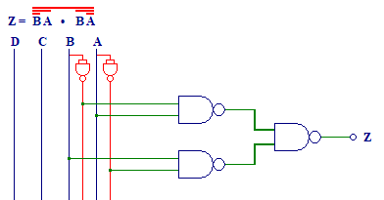

Output for Y(S2)

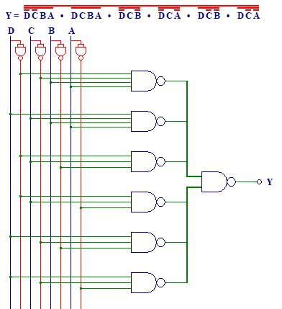

Output for X(C2)

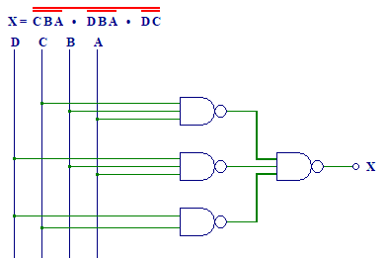

When output= High

Output for W(S1)

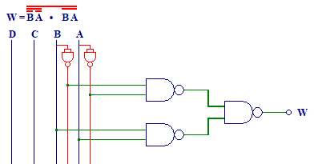

Output for V(S2)

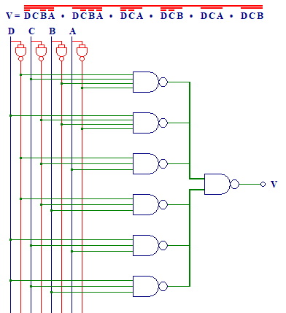

Output for U

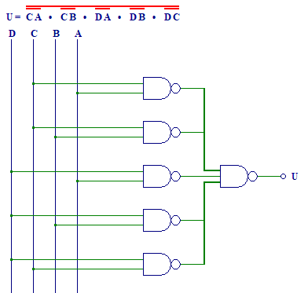

Task 3

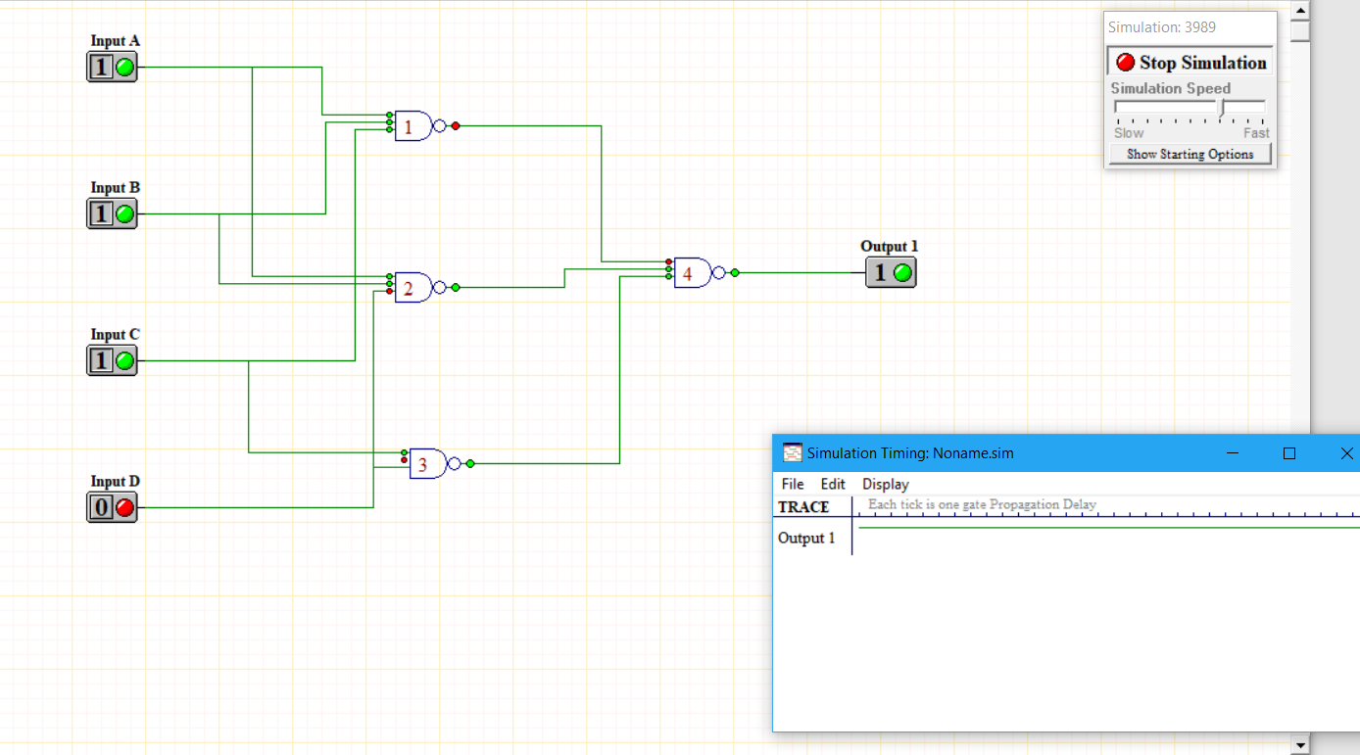

Task 4

Circuit for C2

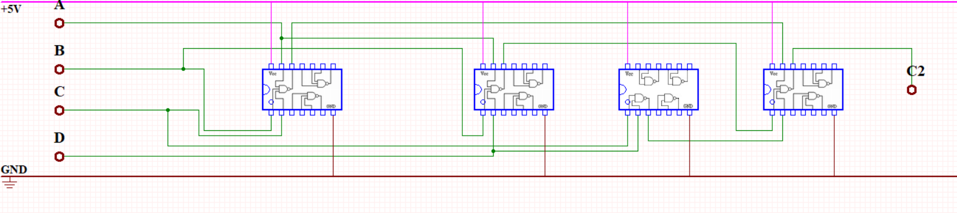

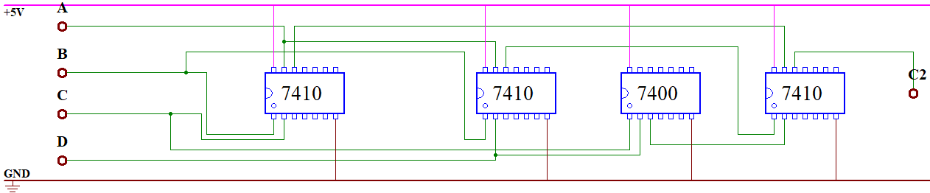

Circuit for C3

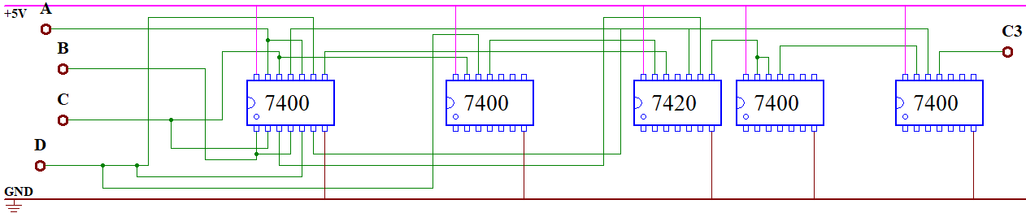

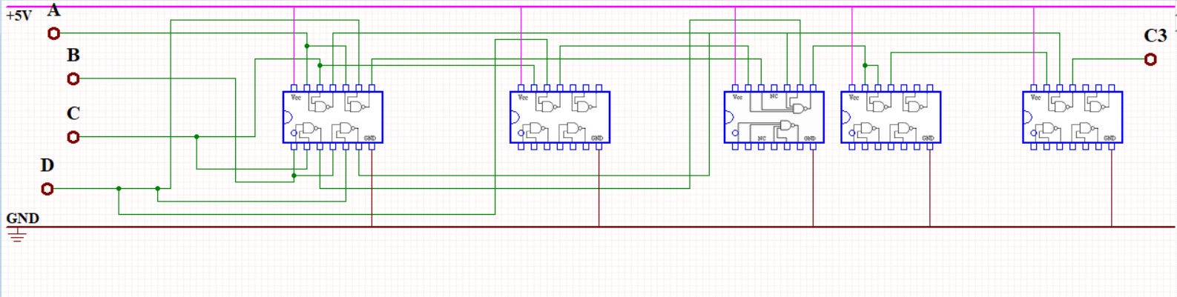

Task 5

